**TCP LEDBAT++ Test Results**

1. Topology used :   
     
   (snbg)_  
    \  
    \______(router)________(recv)  
    /  
    /  
    (snd)

The names inside the parentheses are namespaces. ‘snbg’ and ‘snd’ are senders and send packets to ‘recv’ through ‘router’. ‘snbg’ runs with TCP LEDBAT++ and ‘snd’ runs with TCP cubic.

The bottleneck link has a bandwidth of 10mbit/s and the loss rate is 0.01%.

1. In first case, ‘snbg’ is sending data to ‘recv’ for 50 seconds and during this the ‘snd’ starts sending data for 20 seconds. The throughput graphs are as follows :-

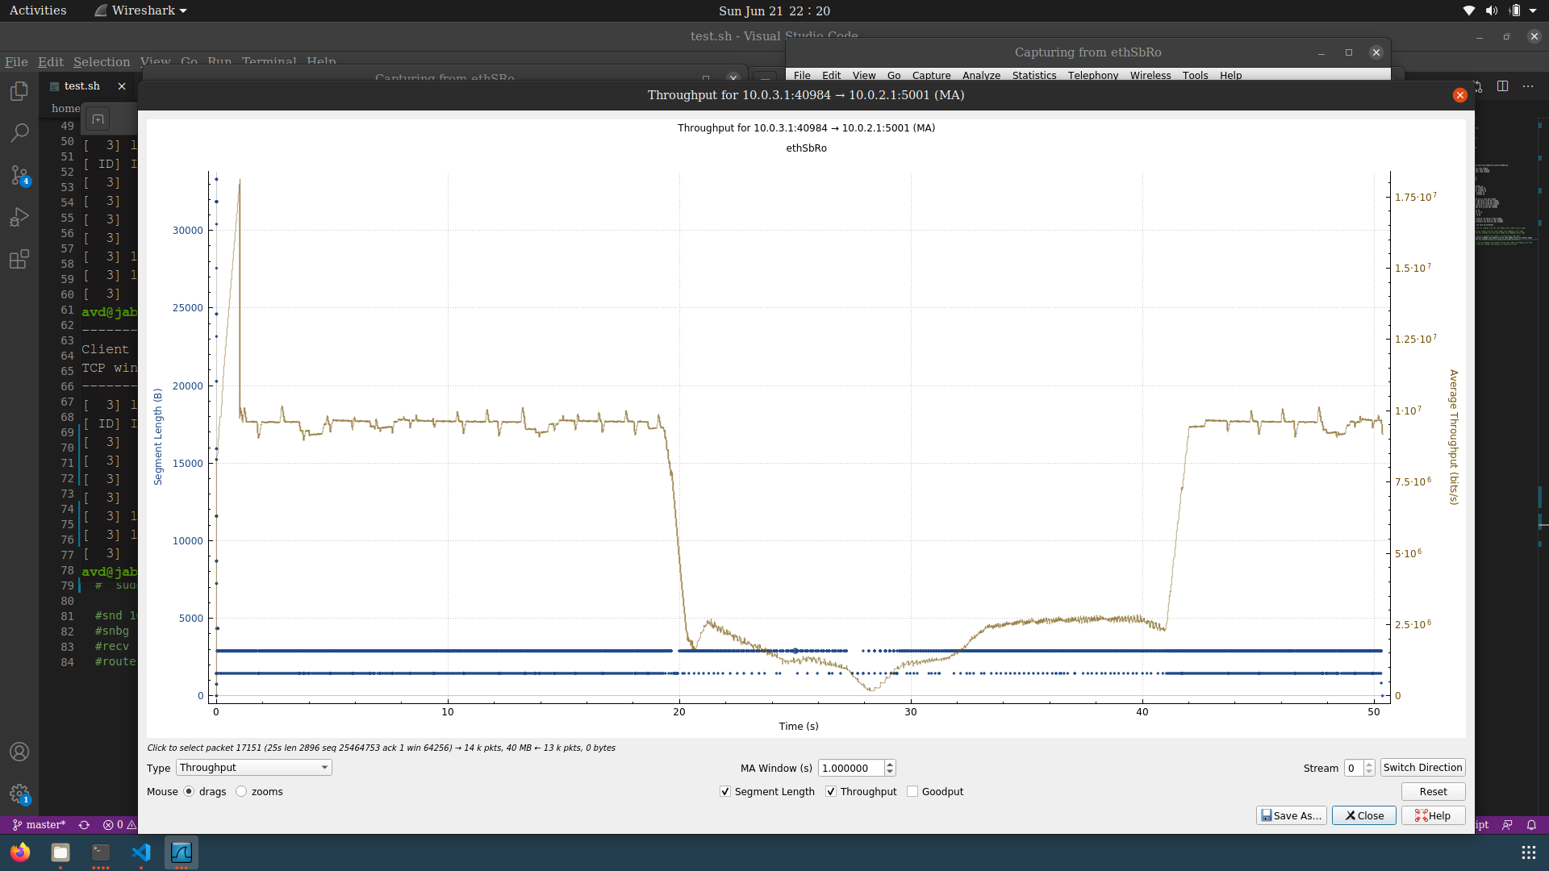

‘snbg’

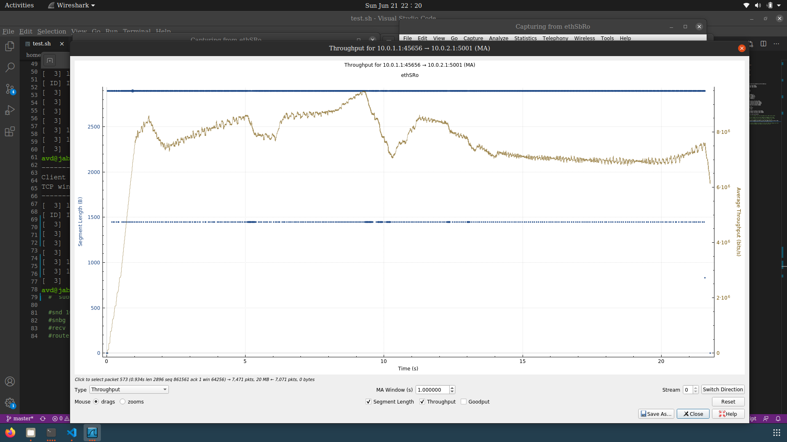

‘snd’

b) In this case ‘snd’ sends data for 80 seconds and during this time ‘snbg’ sends data for 40 seconds

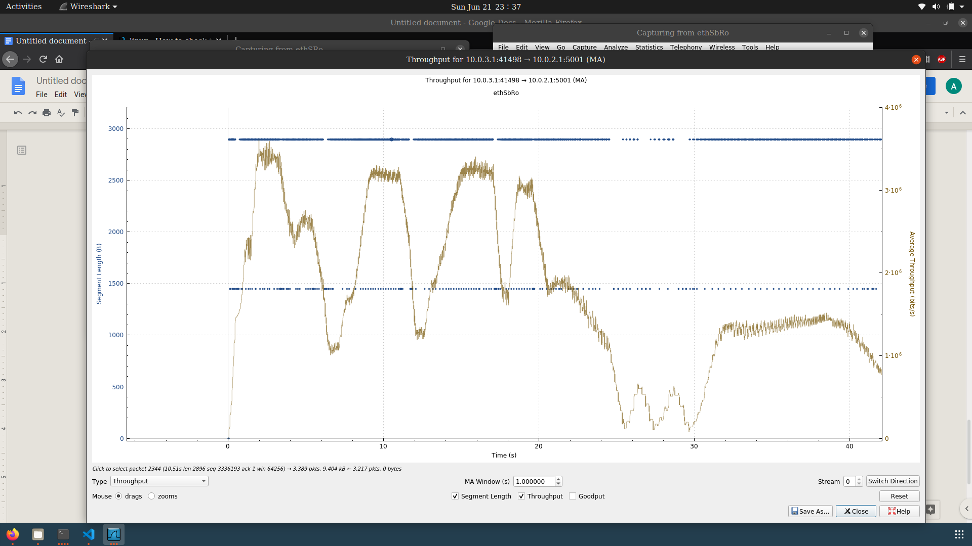

‘snbg’

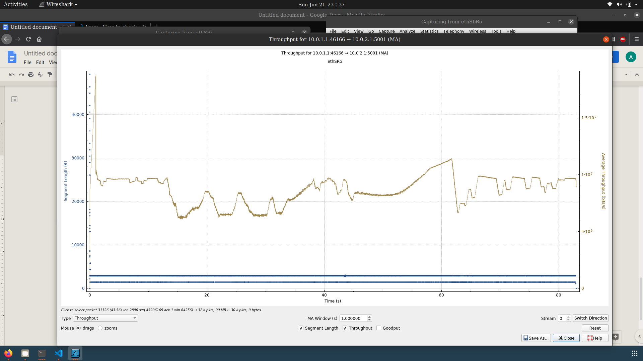

‘snd’

1. Topology used :   
     
   (snbg)_  
    \  
    \______(router)________(recv)  
    /  
    /  
    (snd)

The names inside the parentheses are namespaces. ‘snbg’ and ‘snd’ are senders and send packets to ‘recv’ through ‘router’. Both ‘snd’ and ‘snbg’ run with TCP LEDBAT++.

The bottleneck link has a bandwidth of 10mbit/s and the loss rate is 0.01%.

1. In this case ‘snd’ sends data for 80 seconds and during this time ‘snbg’ sends data for 40 seconds :-

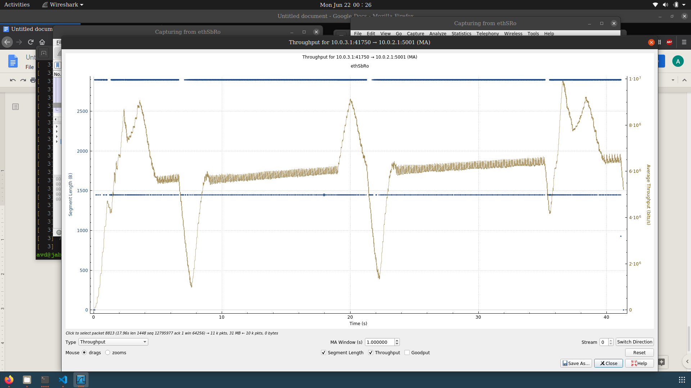

‘snbg’

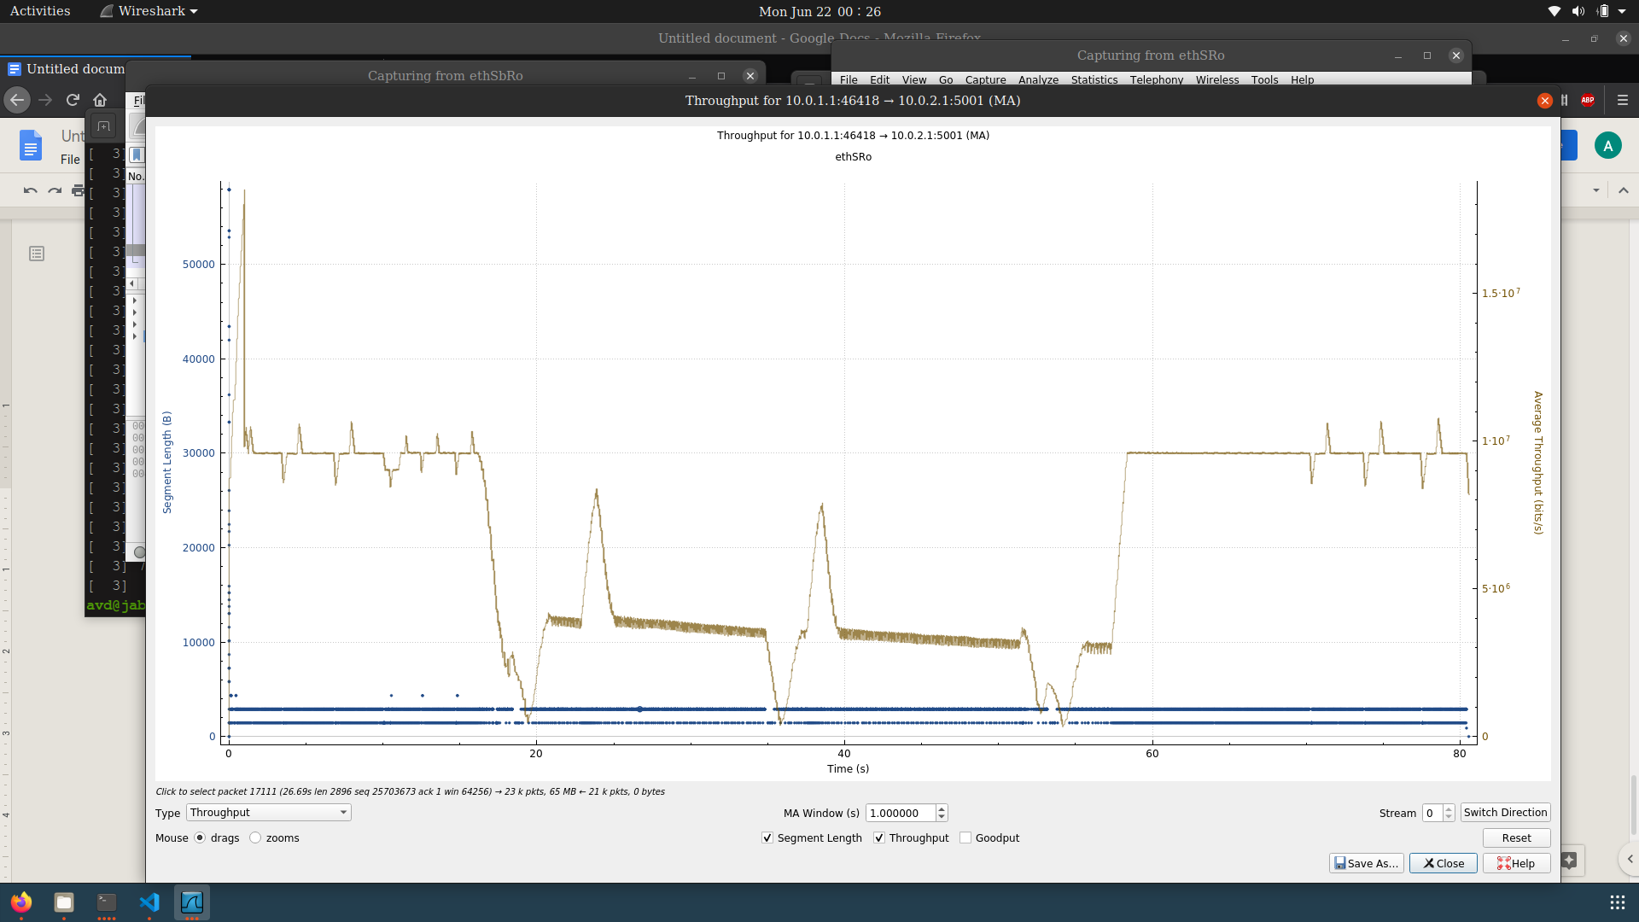

‘snd’